**5. Animation Using Python Program**

**5.1 Aim**

To explore Animation functions in python with the following task objectives

1. Generate 10 frames for animating the shape of the Gaussian Bell function by changing the variance from 2 to 0.2. Also save the frames as tmp_0001, tmp_0002………tmp_0010 as “png file”
2. Create a SINE wave animation “gif” file by Write python program and save it as “sine_wave.gif”
3. Write python program to generate animated “gif” image file for a moving coil effect( Growing Coil animation)

**5.2 Background**

In this experiment:

(i) Using matplotlib and Numpy modules, import matplotlib.animation as animation.use plt.savefig, animation, FuncAnimation, save, matplotlib.animation.PillowWriter functions ofmatplotlib

**5.3 Software Used**

1. Anaconda Navigator
2. Jupyter Notebook

**5.4 Pre Lab Questions**

1. List all the functions used for animation in matplotlib and its uses.

2. Discuss the syntax and arguments of plt.savefig animation.FuncAnimation,

save, matplotlib.animation.PillowWriter functions of matplotlib.

**5.5 Procedure**

1. In Jupyter Notebook click on ‘New Launcher’ and then single click on ’Python3’ under Notebook.
2. Type your program to get the desired output.
3. To view the output, click on ‘Run’ or press ‘Shift+Enter’ to execute the program of the selected cell. Note: In case of error, refer to the error message and do the required changes.

**5.6 Program**

**5.6.1** **Generating Frames for animation**

**Code:**

# Generating Frames for animation - RA2011004010051 - Kunal Keshan

from numpy import *

import matplotlib.pyplot as plt

import time

from matplotlib.animation import FuncAnimation

def f(x,m,s):

return (1.0/(sqrt(2*pi)*s))*exp(-0.5*((x-m)/s)**2)

m=0; s_start=2; s_stop=0.2

s_values=linspace(s_start,s_stop, 10)

x=linspace(m-3*s_start, m+3*s_start, 1000)

max_f=f(m,m,s_stop)

fig=plt.figure()

frame_counter=0

for s in s_values:

y=f(x,m,s)

plt.plot(x,y,'b-')

frame_counter+=1

plt.title('Gaussion/Bell Function')

**Observation:**

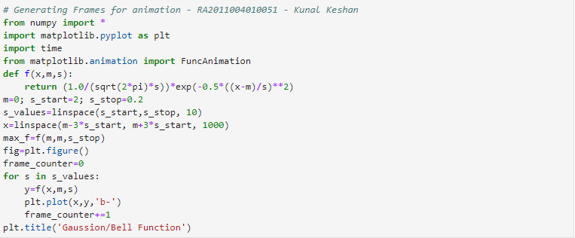

**Output:**

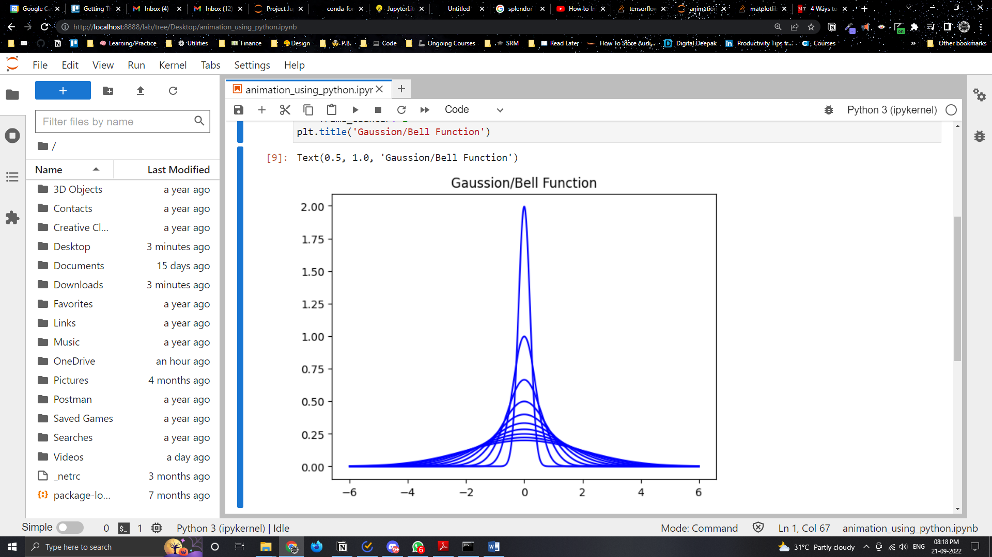

**5.6.2 Creating a SINE wave animation**

**Code:**

# Creating a Sine wave animation - RA2011004010051 - Kunal Keshan

import numpy as np

import matplotlib

from matplotlib import pyplot as plt

from matplotlib.animation import FuncAnimation

plt.style.use('seaborn-pastel')

fig=plt.figure()

ax=plt.axes(xlim=(0,4),ylim=(-2,2))

line,=ax.plot([],[],lw=3)

def init( ):

line.set_data([],[])

return line,

def animate(i):

x=np.linspace(0,4,1000)

y=np.sin(2*np.pi*(x-0.01*i))

line.set_data(x,y)

return line,

anim=FuncAnimation(fig,animate,init_func=init,frames=200,interval=20,blit=True)

writergif=matplotlib.animation.PillowWriter(fps=30)

anim.save('sine____wave.gif',writer=writergif)

**Observation:**

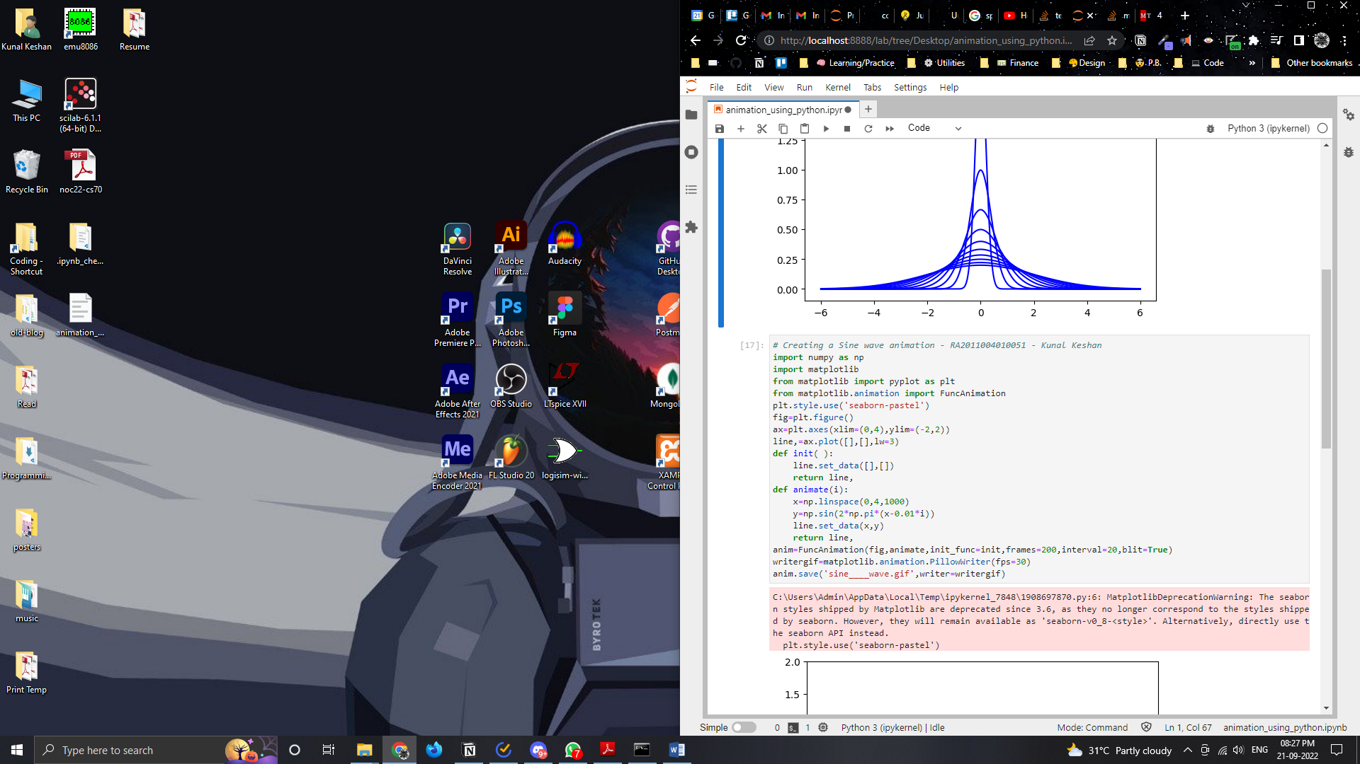

**Output:**

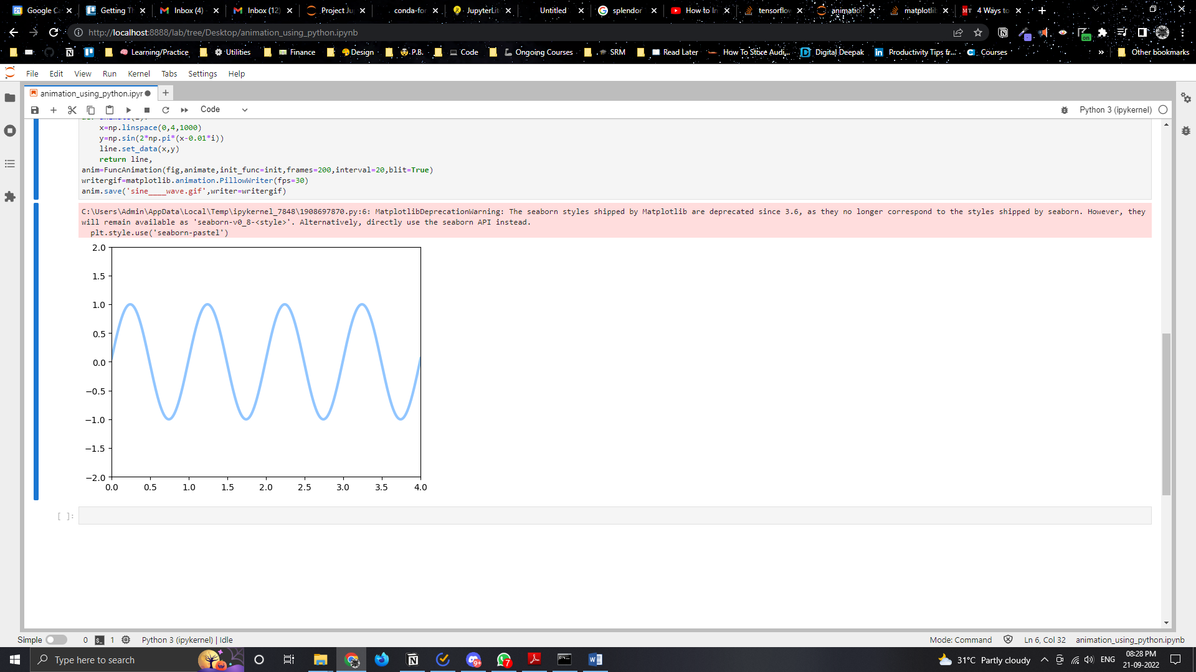

**5.6.3 Creating Growing Coil animation**

**Code:**

# Creating a Growing Coil Animation - RA2011004010051 - Kunal Keshan

import matplotlib

import matplotlib.pyplot as plt

import matplotlib.animation as animation

import numpy as np

plt.style.use('classic')

fig=plt.figure()

ax=plt.axes(xlim=(-50,50),ylim=(-50,50))

line,=ax.plot([],[],lw=2)

def init():

line.set_data([],[])

return line,

xdata,ydata=[],[]

def animate(i):

t=0.1*i

x=t*np.sin(t)

y=t*np.cos(t)

xdata.append(x)

ydata.append(y)

line.set_data(xdata,ydata)

return line,

plt.title('Creating a growing coil with matplotlib!')

plt.axis('off')

anim=animation.FuncAnimation(fig,animate,init_func=init,frames=500,interval=20,blit=True)

writergif=matplotlib.animation.PillowWriter(fps=30)

anim.save('Desktop/growingcoil2.gif',writer=writergif)

**Observation:**

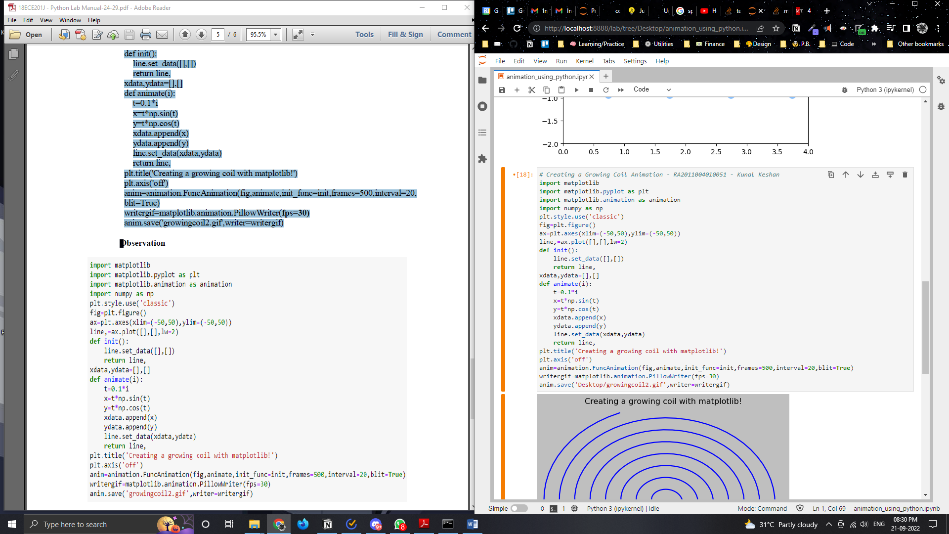

**Output:**

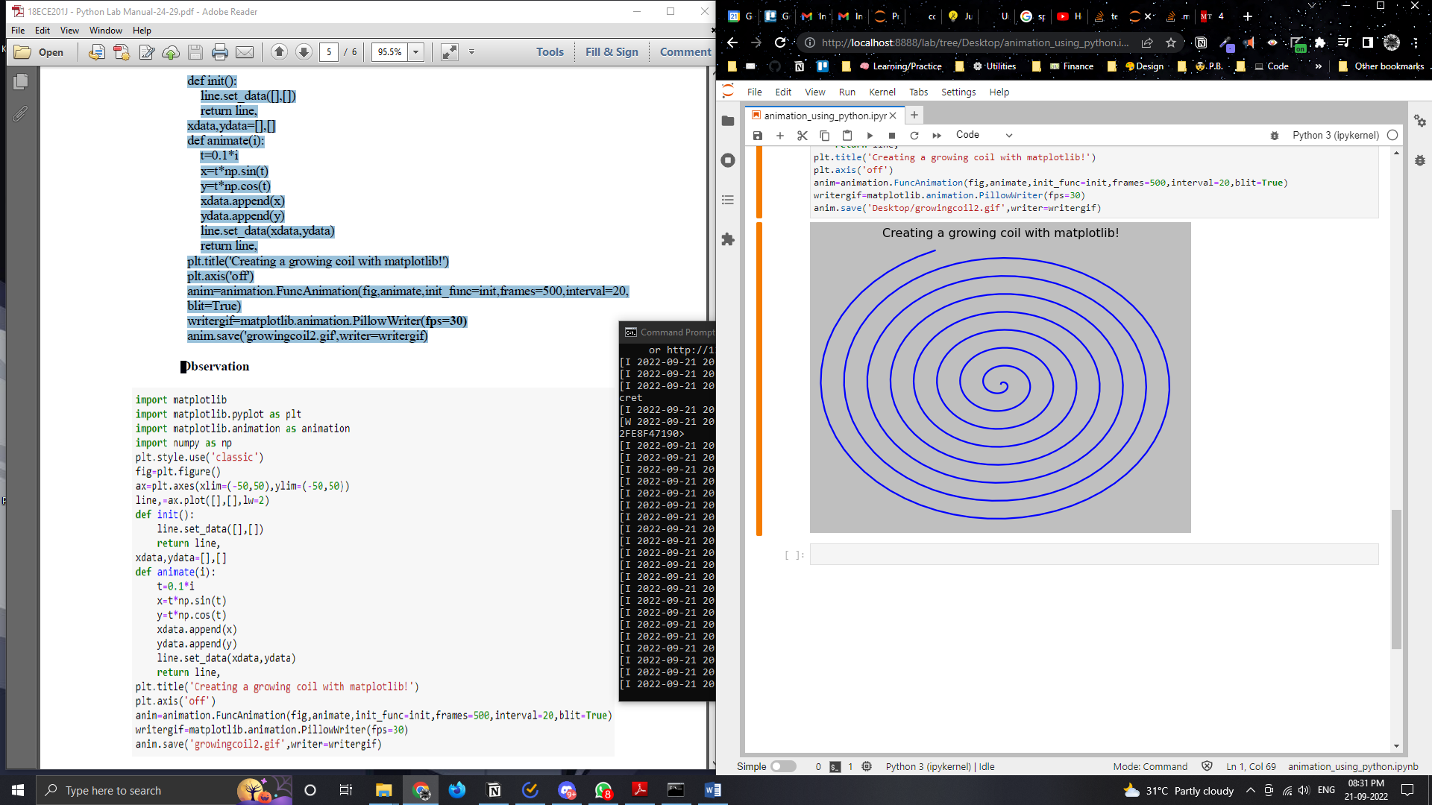

**5.7 Post Lab Questions**

1. Change the frame number to 700 and interval to 10 ,5 and 40 and give your observation in Creating Growing Coil animation. Save the animated file in “MP4”format

2. Make an animation mp4 or gif file from your choice of image frames. You can decide your frame numbers, animation interval and the parameters (**open ended** )

**5.8 Result**

Thus Python is written for creating animation effect files using matplotlib functions

**Post Lab Answers**

1. Change the frame number to 700 and interval to 10 ,5 and 40 and give your observation in Creating Growing Coil animation. Save the animated file in “MP4”format

**Solution:**

**Code:**

# Creating a Growing Coil Animation - RA2011004010051 - Kunal Keshan - Different Intervals

import matplotlib

import matplotlib.pyplot as plt

import matplotlib.animation as animation

import numpy as np

plt.style.use('classic')

fig=plt.figure()

ax=plt.axes(xlim=(-50,50),ylim=(-50,50))

line,=ax.plot([],[],lw=2)

def init():

line.set_data([],[])

return line,

xdata,ydata=[],[]

def animate(i):

t=0.1*i

x=t*np.sin(t)

y=t*np.cos(t)

xdata.append(x)

ydata.append(y)

line.set_data(xdata,ydata)

return line,

plt.title('Creating a growing coil with matplotlib!')

plt.axis('off')

anim=animation.FuncAnimation(fig,animate,init_func=init,frames=700,interval=5,blit=True)

writergif=matplotlib.animation.PillowWriter(fps=30)

anim.save('growingcoil_interval-5.gif',writer=writergif)

**Observation:**

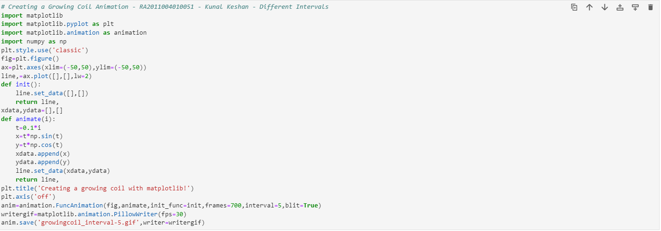

**Output:**

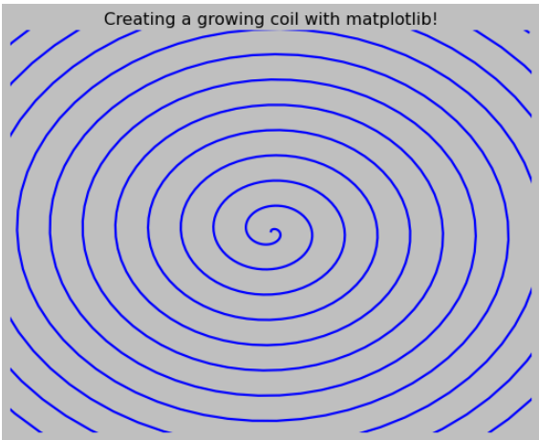

2. Make an animation mp4 or gif file from your choice of image frames. You can decide your frame numbers, animation interval and the parameters (**open ended** )

**Solution:**

**Code:**

# Creating a Growing Coil Animation - RA2011004010051 - Kunal Keshan - Different Intervals

import matplotlib

import matplotlib.pyplot as plt

import matplotlib.animation as animation

import numpy as np

plt.style.use('classic')

fig=plt.figure()

ax=plt.axes(xlim=(-50,50),ylim=(-50,50))

line,=ax.plot([],[],lw=2)

def init():

line.set_data([],[])

return line,

xdata,ydata=[],[]

def animate(i):

t=0.1*i

x=t*np.sin(t)

y=t*np.cos(t)

xdata.append(x)

ydata.append(y)

line.set_data(xdata,ydata)

return line,

plt.title('Creating a growing coil with matplotlib!')

plt.axis('off')

anim=animation.FuncAnimation(fig,animate,init_func=init,frames=700,interval=15,blit=True)

writergif=matplotlib.animation.PillowWriter(fps=30)

anim.save('growingcoil_interval-15.gif',writer=writergif)

**Observation:**

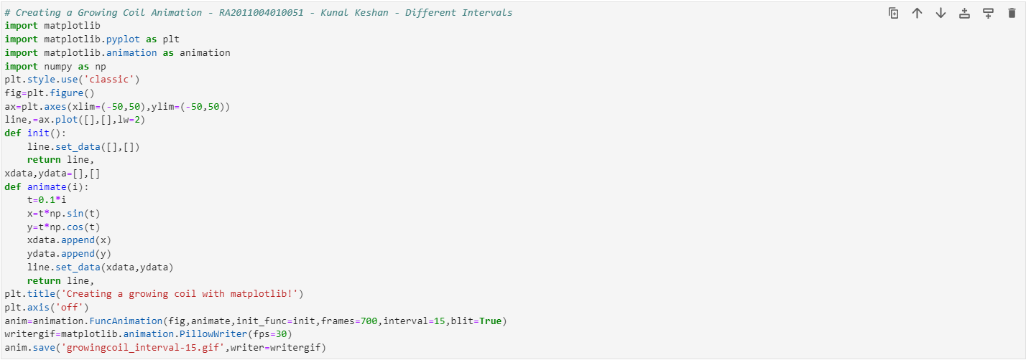

**Output:**

